**ComboBox Control**

The ComboBox control is used to display a drop-down list of various items. It is a combination of a text box in which the user enters an item and a drop-down list from which the user selects an item.

Let's create a combo box by dragging a ComboBox control from the Toolbox and dropping it on the form.

We can populate the list box items either from the properties window or at runtime. To add items to a ComboBox, select the ComboBox control and go to the properties window for the properties of this control. Click the ellipses (...) button next to the Items property. This opens the String Collection Editor dialog box, where you can enter the values one at a line.

**Properties of the ComboBox Control**

The following are some of the commonly used properties of the ComboBox control

1. AllowSelection

Gets a value indicating whether the list enables selection of list items.

2. DataSource

Gets or sets the data source for this ComboBox.

3.ItemHeight

Gets or sets the height of an item in the combo box

4.Items

Gets an object representing the collection of the items contained in this ComboBox.

5. SelectedIndex

Gets or sets the index specifying the currently selected item.

6. SelectedItem

Gets or sets currently selected item in the ComboBox.

7. SelectedText

Gets or sets the text that is selected in the editable portion of a ComboBox.

8. Sorted

Gets or sets a value indicating whether the items in the combo box are sorted.

9.Text

Gets or sets the text associated with this control

**Events of the ComboBox Control**

The following are some of the commonly used events of the ComboBox control −

1.DropDown

Occurs when the drop-down portion of a combo box is displayed.

2.DropDownStyleChanged

Occurs when the DropDownStyle property of the ComboBox has changed.

3.SelectedIndexChanged

Occurs when the SelectedIndex property of a ComboBox control has changed.

**Example**

In this example, let us fill a combo box with various items, get the selected items in the combo box and show them in a list box and sort the items.

Drag and drop a combo box to store the items, a list box to display the selected items, four button controls to add to the list box with selected items, to fill the combo box, to sort the items and to clear the combo box list, respectively.

Add a label control that would display the selected item.

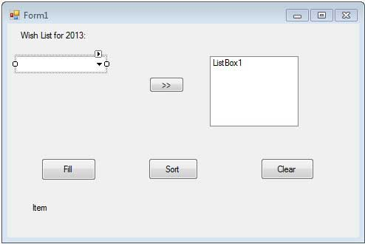

Add the following code in the code editor window

Public Class Form1

Private Sub Form1_Load(sender As Object, e As EventArgs) Handles MyBase.Load

' Set the caption bar text of the form.

Me.Text = "Combo box control"

End Sub

'sends the selected items to the list box

Private Sub Button1_Click(sender As Object, e As EventArgs) Handles Button1.Click

End Sub

'populates the list

Private Sub Button2_Click(sender As Object, e As EventArgs) Handles Button2.Click

ComboBox1.Items.Clear()

ComboBox1.Items.Add("Safety")

ComboBox1.Items.Add("Security")

ComboBox1.Items.Add("Governance")

ComboBox1.Items.Add("Good Music")

ComboBox1.Items.Add("Good Movies")

ComboBox1.Items.Add("Good Books")

ComboBox1.Items.Add("Education")

ComboBox1.Items.Add("Roads")

ComboBox1.Items.Add("Health")

ComboBox1.Items.Add("Food for all")

ComboBox1.Items.Add("Shelter for all")

ComboBox1.Items.Add("Industrialisation")

ComboBox1.Items.Add("Peace")

ComboBox1.Items.Add("Liberty")

ComboBox1.Items.Add("Freedom of Speech")

ComboBox1.Text = "Select from..."

End Sub

'sorting the list

Private Sub Button3_Click(sender As Object, e As EventArgs)

ComboBox1.Sorted = True

End Sub

'clears the list

Private Sub Button4_Click(sender As Object, e As EventArgs)

ComboBox1.Items.Clear()

End Sub

'displaying the selected item on the label

Private Sub ComboBox1_SelectedIndexChanged(sender As Object, e As EventArgs) _

Handles ListBox1.SelectedIndexChanged

Label1.Text = ComboBox1.SelectedItem.ToString()

End Sub

End Class

When the above code is executed and run using Start button available at the Microsoft Visual Studio tool bar, it will show the following window

